Health Plus
Data Profiling
1. Check the different formats of gender in Members.
SELECT DISTINCT gender
FROM Members;
2. Find members with blank email addresses.
SELECT *
FROM Members
WHERE email IS NULL;
3. Find members whose emails are in an invalid format.
SELECT *
FROM Members
WHERE email NOT LIKE '%@%.%';
4. Find claims where consultation_id is blank.
SELECT *
FROM Claims
WHERE consultation_id IS NULL;
5. Find claims where insurance_provider is blank.
SELECT *
FROM Claims
WHERE insurance_provider IS NULL;
6. Find billing records where consultation_id is blank.
SELECT *
FROM Billing
WHERE consultation_id IS NULL;
7. Find payments where payment_mode is blank.
SELECT *
FROM Payments
WHERE payment_mode IS NULL;

Data Cleaning:
1. Standardize the gender values in the Members table.
UPDATE Members
SET gender =
CASE
WHEN LOWER(TRIM(gender)) IN ('male', 'm')
THEN 'Male'
WHEN LOWER(TRIM(gender)) IN ('female', 'f')
THEN 'Female'
ELSE gender
END;
SET SQL_SAFE_UPDATES = 0;
2. Standardize the email format in the Members table.
UPDATE Members
SET email =
CASE
WHEN email LIKE '%gmail' AND email NOT LIKE '%@%'
THEN REPLACE(email, 'gmail', '@gmail')
END
WHERE email NOT LIKE '%@%.%';

Data Analysis:
1. What is the total number of members, and how are they distributed across membership types and gender?
SELECT membership_type, gender, COUNT(*)
FROM Members
GROUP BY membership_type, gender
ORDER BY COUNT(member_id) DESC;
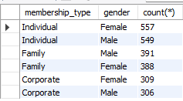

2. Which cities have the highest number of members?
SELECT city, COUNT(*) AS total_members
FROM Members
GROUP BY city
ORDER BY total_members DESC;
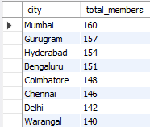

3. What is the total revenue generated, average bill value, and contribution of consultation, laboratory, and medicine charges?
SELECT
COUNT(*) AS total_bills,
ROUND(SUM(total_amount), 2) AS total_revenue,
ROUND(AVG(total_amount), 2) AS average_bill_value,
ROUND(SUM(consultation_charges), 2) AS consultation_revenue,
ROUND(SUM(lab_charges), 2) AS lab_revenue,
ROUND(SUM(medicine_charges), 2) AS medicine_revenue
FROM Billing;

4. How many specialists are there?
SELECT COUNT(*) AS Total_no_of_Specialists
FROM Specialists;


5. What is the total revenue generated from billing?
SELECT SUM(total_amount) AS Total_Revenue
FROM Billing;


6. What is the highest and lowest billing amount?
SELECT
MAX(total_amount) AS Highest_Bill,
MIN(total_amount) AS Lowest_Bill
FROM Billing;


7. How many members are there in each membership type?
SELECT membership_type, COUNT(member_id) AS Total_Members
FROM Members
GROUP BY membership_type;



8. How many consultations are there for each consultation mode?
SELECT consultation_mode, COUNT(consultation_id) AS Total_Consultations
FROM Consultations
GROUP BY consultation_mode;


9. How many consultations are there for each consultation status?
SELECT status, COUNT(consultation_id) AS Total_Consultations
FROM Consultations
GROUP BY status;


10. Which specializations have more than 100 consultations?
SELECT s.specialization, COUNT(c.consultation_id) AS Total_Consultations
FROM Specialists s
INNER JOIN Consultations c
ON s.specialist_id = c.specialist_id
GROUP BY s.specialization
HAVING COUNT(c.consultation_id) > 100
ORDER BY Total_Consultations DESC;
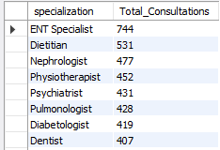

11. Which are the top 5 clinics based on the number of consultations?
SELECT cl.clinic_name, COUNT(c.consultation_id) AS Total_Consultations
FROM Clinics cl
INNER JOIN Consultations c
ON cl.clinic_id = c.clinic_id
GROUP BY cl.clinic_name
ORDER BY Total_Consultations DESC
LIMIT 5;


12. Rank specialists based on consultation fee from highest to lowest.
SELECT first_name, last_name, specialization, consultation_fee,
ROW_NUMBER() OVER (
ORDER BY consultation_fee DESC
) AS rnk
FROM Specialists;
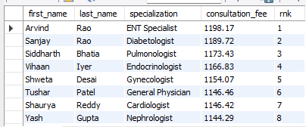

13. Rank specialists based on consultation fee within each specialization.
SELECT first_name, last_name, specialization, consultation_fee,
ROW_NUMBER() OVER (
PARTITION BY specialization
ORDER BY consultation_fee DESC
) AS rnk
FROM Specialists;
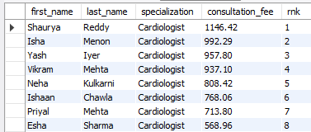

14. Display the previous consultation fee for each specialist.
SELECT first_name, last_name, specialization, consultation_fee,
LAG(consultation_fee) OVER (
ORDER BY consultation_fee DESC
)
FROM Specialists;
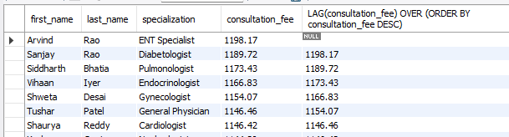

15. Display the next consultation fee for each specialist.
SELECT first_name, last_name, specialization, consultation_fee,
LEAD(consultation_fee) OVER (
ORDER BY consultation_fee DESC
)
FROM Specialists;
